KWAME NKRUMAH UNIVERSITY OF SCIENCE AND TECHNOLOGY KUMASI, GHANA


COLLEGE OF ENGINEERING
DEPARTMENT OF ELECTRICAL/ELECTRONIC ENGINEERING
COE 381 (MICROPROCESSORS)
SOLAR POWERED AUTOMATIC PLANT WATERING SYSTEM

GROUP MEMBERS
- ABASS OSMAN - 7340923
- ADU SERWAH STEPHANIE – 7341423
- GIDEON AWONTEME ASIAK – 7342623
- ADU RAPHAEL OFORI – 7341323
- AVEVOR KAFUI - 7342723
- SIAW PRINCE AMPONSAH - 1874422

DATE: APRIL 4TH, 2026

ACKNOWLEDGEMENT
We thank God for good health in strength and in mind for taking us through this project from start to finish.

ABSTRACT
This project is a tinker cad design of a simple yet very helpful and economical solar powered plant watering system. It uses simple components to achieve this.

Contents
ACKNOWLEDGEMENT 2
ABSTRACT 2
LIST OF FIGURES 4
CHAPTER ONE 5
INTRODUCTION 5
1.1 STATEMENT OF PROBLEM 5
CHAPTER TWO 6
METHODOLOGY 6
2.1 COMPONENTS USED FOR IMPLEMNTING THE PROJECT 6
CHAPTER THREE 9
CONCLUSION 9
CHAPTER 4 10
RECOMMENDATION 10

LIST OF FIGURES
Figure 1: Arduino Uno controller……………………………………….………………...…..6
Figure 2: Soil moisture sensor………………………………………………………………...6
Figure 3: Pv panel………………………….……………...………………………………….7
Figure 4: Wiring connections…………………………...………...……...……………………7

CHAPTER ONE

INTRODUCTION
  - STATEMENT OF PROBLEM
Traditional methods of plant irrigation, such as manual watering or fixed-timer systems, are often inefficient and labour-intensive. These methods do not account for real-time soil conditions, frequently leading to water wastage through over-irrigation or crop stress due to under-watering. Furthermore, many gardening environments lack easy access to the electrical grid, necessitating a self-sustaining power solution.This project addresses these challenges by designing and implementing a Solar-Powered Automatic Plant Watering System controlled by an Arduino microcontroller.
The project aims to solve the following specific technical and operational problems:
- Resource Inefficiency: Traditional "morning and evening" watering schedules do not adapt to fluctuating environmental needs. This project seeks to optimize water and power consumption by delivering moisture only when sensors indicate a specific dryness threshold.
- Power Autonomy: In off-grid or outdoor settings, maintaining a consistent power supply is difficult. This project implements a solar-harvesting circuit to ensure the Arduino and water pump operate independently of the main power grid.
- Sensor-Driven Accuracy: To move beyond human guesswork, the project evaluates whether soil moisture sensor data provides a sufficiently reliable metric to automate irrigation accurately, ensuring plants receive the precise amount of water required at any given moment. PROJECT OBJECTIVES
The goals of this project are to.
- Use water for garden more efficiently to save money
- Minimize labour required to irrigate garden.
- Promote use of clean energy for farming/gardening
- Obtain a good score at the end of the course evaluation

CHAPTER TWO

METHODOLOGY

2.1 COMPONENTS USED FOR IMPLEMNTING THE PROJECT

1. Arduino uno

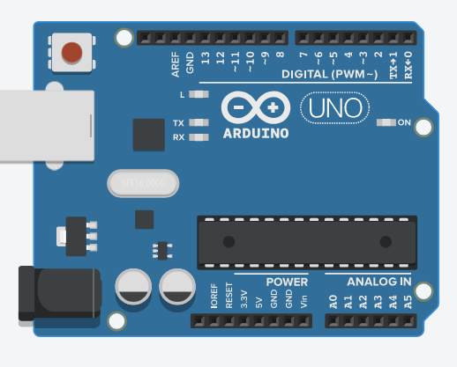
Figure 1 Arduino Uno microcontroller

2. Soil Moisture Sensor

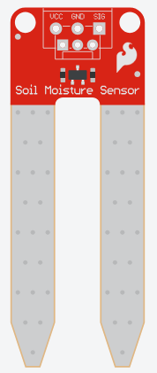
Figure 2 Soil moisture sensor

3. Solar pv

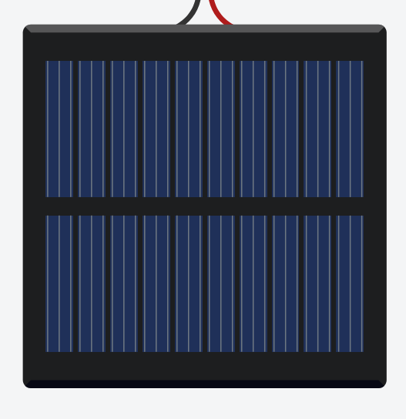
Figure 3 Pv panel

4. Motor pump
5. Breadboard
6. connecting wires
7. PV batteries
2.2 BREAKDOWN OF PROJECT SIMULATION IN TINKERCAD
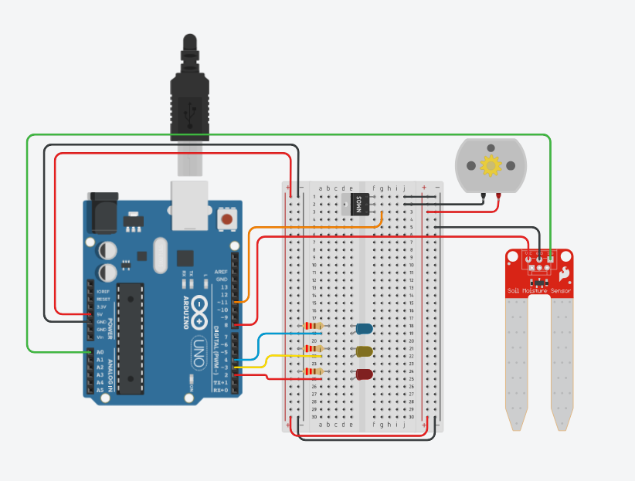
Figure 4 Wiring connections

The entire project was designed and implemented in tikercad, the circuit connections is shown in the picture above.

The soil moisture sensor’s analog output is connected to A0 on the Arduino. Digital pin 8 controls power to the sensor (turned ON only during reading to prevent corrosion).

LEDs: Red (Pin 2 – Dry), Yellow (Pin 3 – Optimal), Blue (Pin 4 – Wet).

Water pump is controlled via Pin 11.

Solar panel and battery supply power to the Arduino and pump circuit.

2.3 TESTING AND OBSERVATION
The system was tested in Tinkercad by simulating different soil conditions:
- Dry soil simulation triggered the pump and Red LED correctly.
- Adding “water” (changing sensor value) turned the pump OFF and activated the Yellow or Blue LED.
- The solar panel successfully powered the circuit in the simulation.
The thresholds may need real-world calibration depending on soil type and sensor variation. The sensor power control technique helps prolong the life of the moisture sensor.

CHAPTER THREE

CONCLUSION
- The Solar Powered Automatic Plant Watering System was successfully designed and simulated using Tinkercad and Arduino. The system effectively monitors soil moisture and automates irrigation while being powered by renewable solar energy.
- It achieves the project objectives of efficient water usage, reduced labour, and promotion of clean energy. The visual LED indicators and serial monitoring provide clear feedback on system status. This project demonstrates the practical application of microprocessors in solving everyday agricultural challenges.

CHAPTER 4

RECOMMENDATION
- For future improvements and real-world implementation, the following are recommended:
- Integrate a small LCD or OLED display to show moisture percentage and status.
- Add a water level sensor for the reservoir to prevent the pump from running dry.
- Implement hysteresis in the code to avoid rapid pump switching.
- Replace the simulation with a physical prototype using a relay module for the pump.
- Add Wi-Fi (ESP8266/ESP32) for remote monitoring via a mobile app.
- Use a larger solar panel and battery for outdoor field applications.
- Calibrate the sensor thoroughly in different soil types before deployment.

